PRESS RELEASE - For immediate release

THE BRACKETEER wins six Global Media Awards at SEMA 2019.

Las Vegas, NV, November 6, 2019 – The Bracketeer, manufacturer of the world’s number one selling Universal Car Fire Extinguisher Bracket, was awarded six prestigious Global Media Awards at SEMA 2019.

The SEMA Global Media Awards Program recognizes those companies that manufacture specialty equipment products and accessories that would have mass appeal to consumers in countries outside the United States. The products are voted on by a prestigious group of international journalists who serve as judges.

This year's program included about 30 judges from 22 countries. Each judge carefully reviewed and evaluated nearly 3,000 product entries at the SEMA Show before selecting the products that they felt would resonate and appeal most to consumers in their home countries.
The Bracketeer UFEB1317/D provides a quick and secure solution to mount a fire extinguisher in most modern and classic passenger cars and commercial vehicles.

The Bracketeer is not only for automotive, off-road and motorsport enthusiasts; it is now being used by corporations and government bodies in their fleet vehicles including; school districts, counties and municipalities, airports, mining companies, National Parks, Fisheries and Wildlife, multi-nationals, trades, transportation, and most major autonomous vehicle trials across the U.S.

The Patented Universal Car Fire Extinguisher Bracket simply clamps onto the front or rear of the seat rails onto the passenger seat of most modern vehicles. For vehicles with a classic or traditional bolt-on seat frame design, the ends of the bracket are inverted and secured onto the factory mounting bolts.
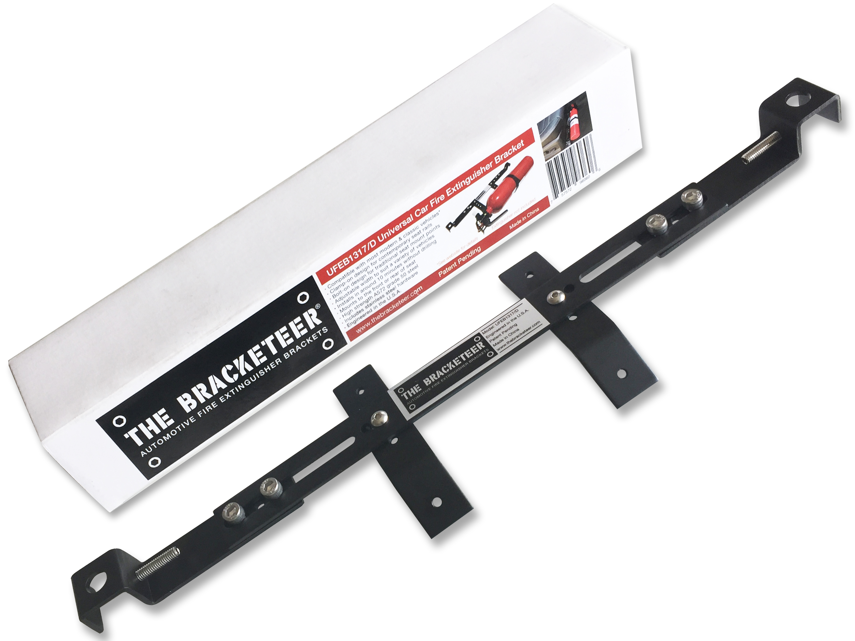
“I really love this product as it uses clever thinking to solve an issue we all have [mounting a fire extinguisher in a car]. Rather than making custom brackets for different vehicles and different seats, it is one simple product that gets the job done quickly and easily.” Said Matt Raudonikis from 4x4 Australia.

With over 171,000* auto fires in the U.S. each year, causing over 345 deaths, 1,300 injuries and $1.1 billion in property loss, The Bracketeer Automotive Universal Fire Extinguisher Bracket is a small investment for the added safety and security it delivers to vehicle owners and drivers alike.

The bracket can also provide a quick and secure mounting location for car audio and electronic equipment and performance enhancing products in vehicles.

For more information go to www.thebracketeer.com or email simon@thebracketeer.com
High-resolution images go to www.thebracketeer.com/media

*NFPA (National Fire Protection Association) annual survey 2014-2016

About: The Bracketeer, is headquartered in San Clemente California, and was founded by car enthusiast and modifier Simon Wehr. Starting from a one-off hand made fire extinguisher bracket for his 2011 SS Camaro, Simon posted images of his creation on a car forum to share as a DIY idea. It was so embraced by Camaro owners that the concept quickly evolved into a business, with orders flowing in from around the globe. The overnight success promoted the idea for a truly universal bracket that could achieve a secure installation, quickly and easily in nearly any modern and classic vehicle, and so The Bracketeer Automotive Universal Fire Extinguisher Bracket was born. The rest, as they say, is history.

