PRESS RELEASE - For immediate release

THE BRACKETEER exhibits for the first time at SEMA 2019.

San Clemente, CA, August 11, 2019 – The Bracketeer, manufacturer of the world’s number one selling Universal Car Fire Extinguisher Bracket will exhibit for the first time at SEMA 2019, at booth 71,000 in the Racing Annex & Grand Lobby off Central Hall.

The Bracketeer UFEB1317/D provides a quick and secure solution to mount a fire extinguisher in most modern and classic passenger cars and commercial vehicles including: Audi, BMW, Chevrolet, Chrysler, Dodge, Ferrari, Ford, Genesis, GMC, Holden, Hyundai, Jeep, Mazda, McLaren, Mercedes Benz, Nissan, Oldsmobile, Opel, Pontiac, Porsche, Scion, SEAT, Skoda, Subaru, Toyota, Vauxhall, Volvo, Volkswagen and more.
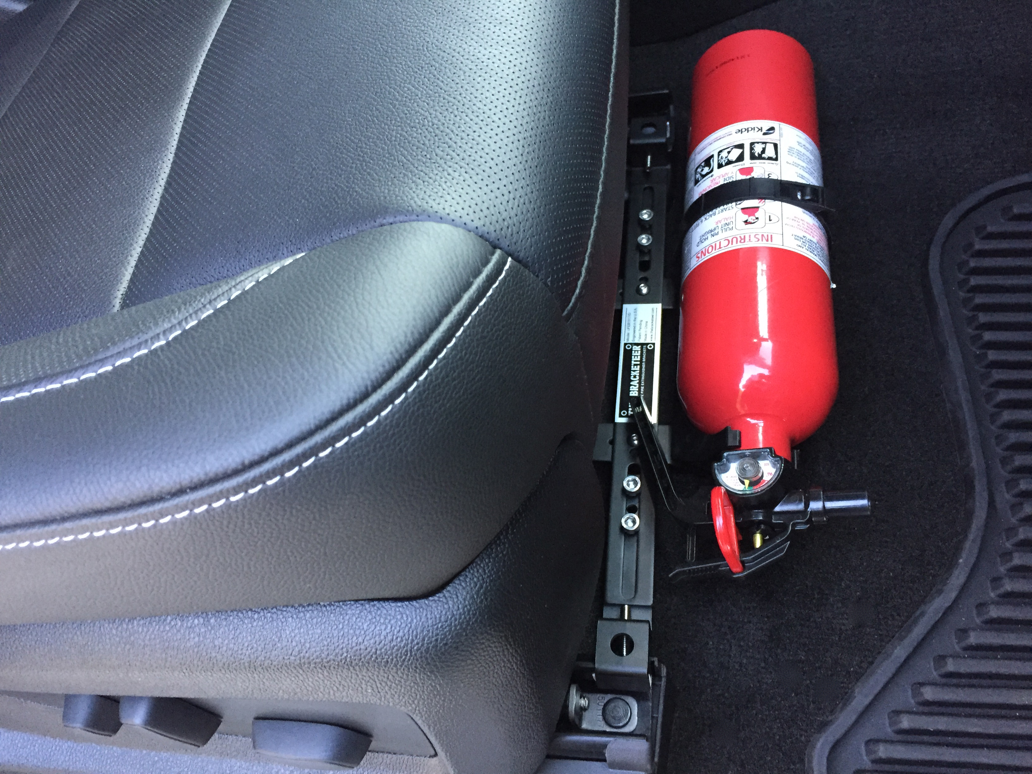
The Bracketeer is not only for automotive, off-road and motorsport enthusiasts; it is now being used by corporations and government bodies in their fleet vehicles including; school districts, counties and municipalities, airports, mining companies, National Parks, Fisheries and Wildlife, multi-nationals, trades, transportation, and most major autonomous vehicle trials across the U.S.

The Patented Universal Car Fire Extinguisher Bracket simply clamps onto the front or rear of the seat rails onto the passenger seat of most modern vehicles. For vehicles with a classic or traditional bolt-on seat frame design, the ends of the bracket are inverted and secured onto the factory mounting bolts.

The Bracketeer Universal Car Fire Extinguisher Bracket is constructed of high-grade A572 steel, and supplied with stainless steel fasteners and hex keys. It is also compatible with the cradles supplied with most popular brands of compact fire extinguishers.
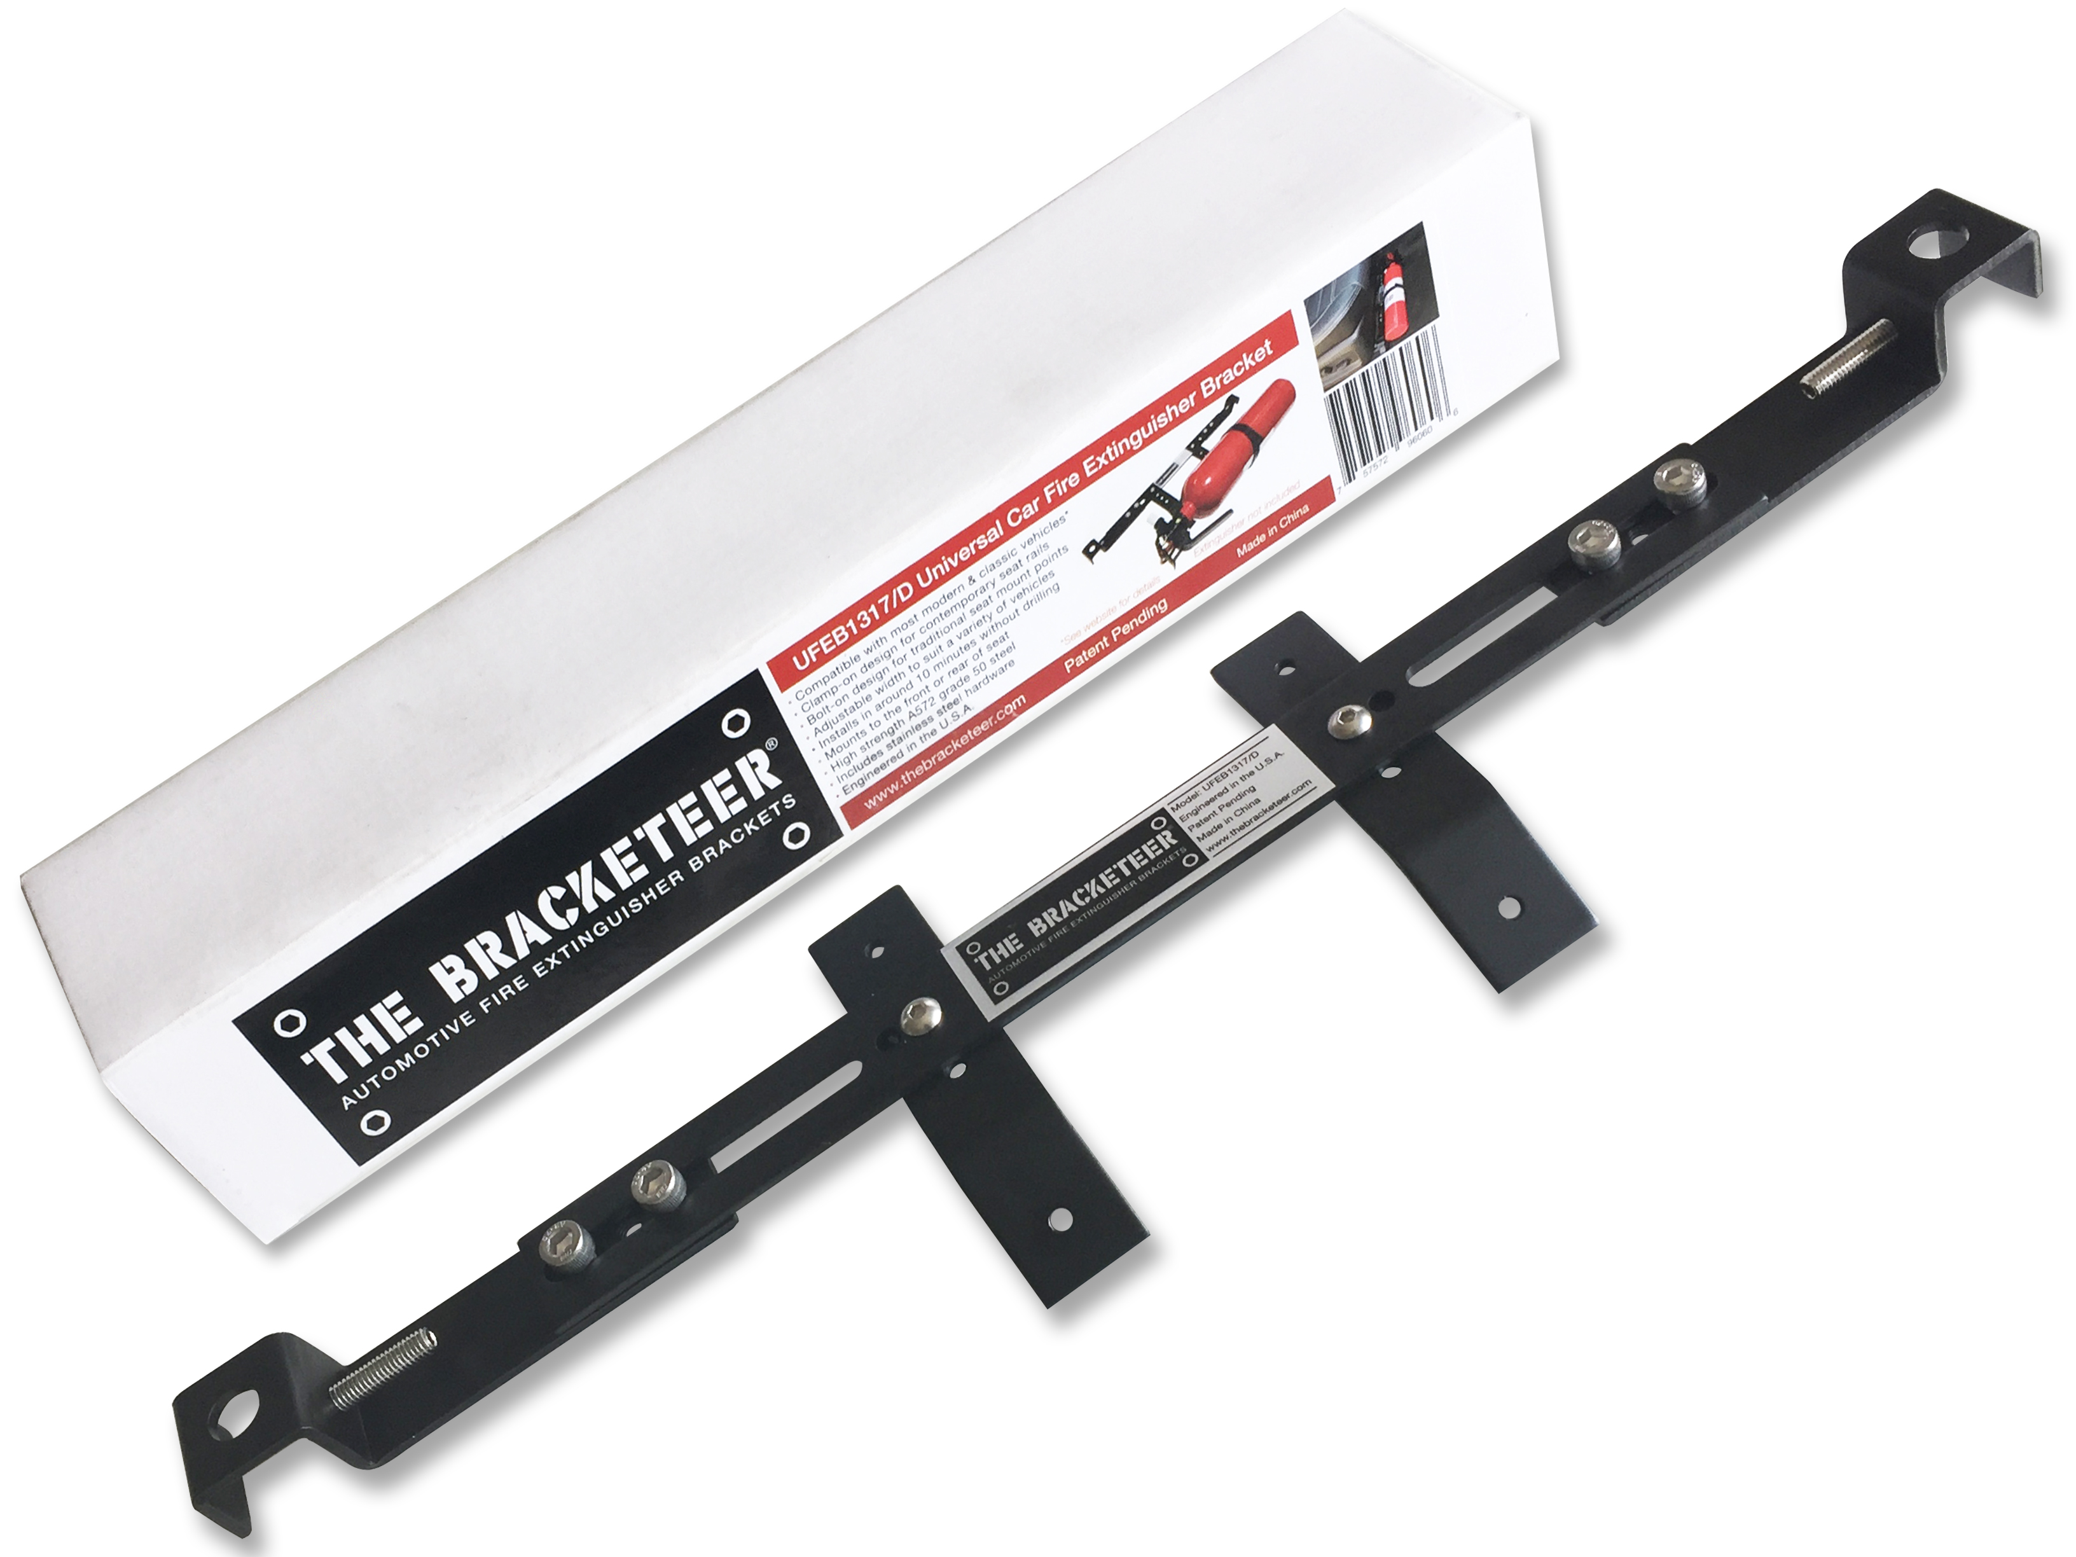
“After personally putting out four car fires in my lifetime, I have been an advocate for having fire extinguishers in every vehicle,” said Simon Wehr, Founder and President of The Bracketeer. “While there are products on the market that are purpose-built for specific makes and model of cars, I wanted to design something that was truly universal and would fit as many different vehicles as possible. The Bracketeer is simple and easy to install without drilling any holes (and just as easy to remove), and provides a secure mounting solution that puts the extinguisher within easy reach, but out of the way of passengers.” Said Wehr.

With over 171,000* auto fires in the U.S. each year, causing over 345 deaths, 1,300 injuries and $1.1 billion in property loss, The Bracketeer Automotive Universal Fire Extinguisher Bracket is a small investment for the added safety and security it delivers to vehicle owners and drivers alike.

The bracket can also provide a quick and secure mounting location for car audio and electronic equipment and performance enhancing products in vehicles.

The Bracketeer Automotive Universal Fire Extinguisher Bracket is available to buy online and has an MSRP of $59.90.

For more information go to www.thebracketeer.com or email simon@thebracketeer.com
High-resolution images go to www.thebracketeer.com/media

*NFPA (National Fire Protection Association) annual survey 2014-2016

About: The Bracketeer, is headquartered in San Clemente California, and was founded by car enthusiast and modifier Simon Wehr. Starting from a one-off hand made fire extinguisher bracket for his 2011 SS Camaro, Simon posted images of his creation on a car forum to share as a DIY idea. It was so embraced by Camaro owners that the concept quickly evolved into a business, with orders flowing in from around the globe. The overnight success promoted the idea for a truly universal bracket that could achieve a secure installation, quickly and easily in nearly any modern and classic vehicle, and so The Bracketeer Automotive Universal Fire Extinguisher Bracket was born. The rest, as they say, is history.

